A generic photo of high school students graduating from their last year of schooling.

MOSMAN

Nine Redlands students celebrate IB and HSC achievements
Redlands, Mosman Daily
January 14, 2019 6:24pm
Subscriber only

•
- Star student chooses medicine at uni
- From Monte to Ivy League
Cremorne’s Redlands — formerly known as SCECGS Redlands — has celebrated an outstanding 2018, with exceptional results in the Higher School Certificate (HSC) and International Baccalaureate (IB) examinations.
A total of 18 pupils achieved an ATAR of 98 or higher, and 41 students achieved an ATAR of 95 or higher.
For the graduating class as a whole, 56 per cent achieved an ATAR of 90 or higher in 2018.
Fifty-five per cent of the class undertook the IB last year and the remaining 45 per cent went with the HSC.
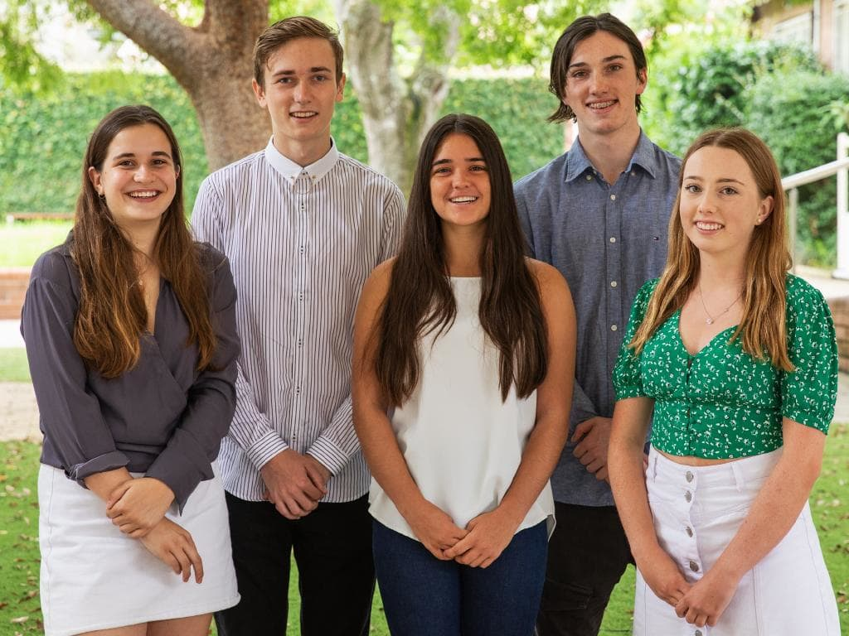
Redlands students Georgia Joyce, Jackson Wiebe, Katherine Stuart, Montegah Grace and Emma Green.

As a result, seven students achieved an ATAR of 99 or more in their examinations.
Redlands 2018 Dux of IB, prefect and captain of athletics John Economides achieved an ATAR of 99.70 and plans to study mathematics and computer science at either UNSW or a USA university.
Last year’s school captain Jasmine Zhou, sports caption Jemma Donoghue, service prefect Hugh Smylie, Hai Yu ‘Heidi’ Fang and Lola Coles all achieved an ATAR of 99.40.
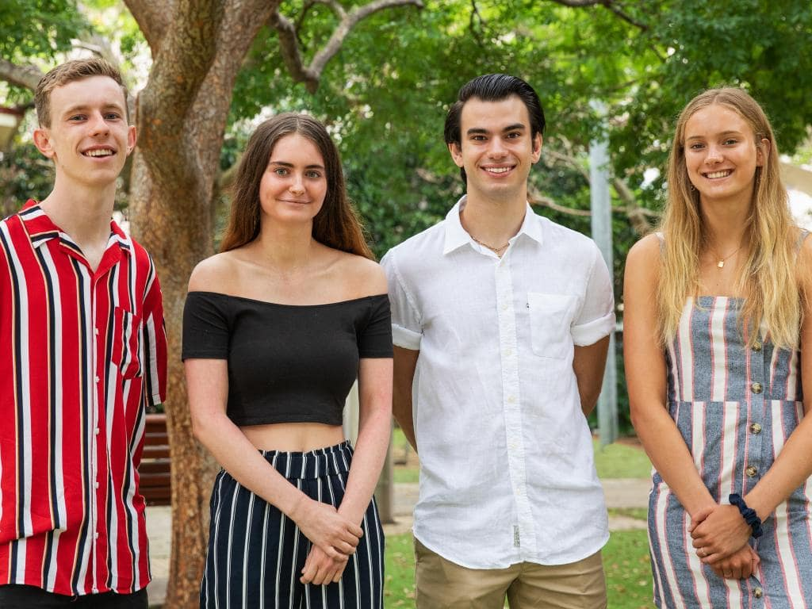
Redlands students Hugh Smylie, Lola Coles, John Economides and Jemma Donoghue.

Heidi has been offered a place at Oxford University to student mathematics and philosophy. Jasmine plans to study liberal arts in the USA, Jemma commerce and law at Sydney university, Hugh medical science at Sydney University and Lola communications and law at UTS.
The 2018 Dux of HSC Arthur Allshire achieved an ATAR of 99.25 and plans to undertake engineering science at the University of Toronto.
“I congratulate all students on a successful 2018 at Redlands and wish them all the best in their future endeavours,” principal Peter Lennox said.
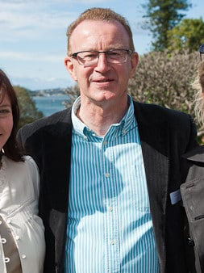
Redlands principal Dr Peter Lennox was thrilled with the efforts of graduating students last year.A generic picture of high school students holding their graduation hats.
“Our students’ success is testament to their hard work, dedication and contribution to both the School and local communities through performing arts, sport and service.
“On behalf of the entire school community, I wish to congratulate all the students, and their HSC counterparts, and wish them all the best in their future endeavours.”

WHAT THE STUDENTS ACHIEVED THROUGHOUT 2018
• Redlands 2018 Dux of IB, prefect and captain of athletics John Economides achieved an ATAR of 99.70 and plans to study mathematics and computer science at either UNSW or a USA university. For his IB, John studied English, mathematics, physics, economics, computer science and Latin. He also represented the school in athletics, football and basketball.
• Last year’s school captain Jasmine Zhou achieved an IB score of 42/45 — equating to an ATAR of 99.40 — and plans to study liberal along with business and management, mandarin and visual arts. Jasmine represented the school in hockey, indoor hockey and debating. She also participated in the orchestra and strings ensemble.
• Last year’s sports captain Jemma Donoghue also achieved an IB score of 42/45. She studied English, mathematics, economics, computer science, business and management, and Spanish for her International Baccalaureate. Jemma plans to undertake a degree in commerce and law at Sydney University. She also represented the school in netball, basketball, athletics, cross country, swimming, dance and water polo — representing the state and the independent Schools Association in Netball.
• Last year’s service prefect Hugh Smylie achieved an IB score of 42/45 and is planning to study medical science at Sydney University. To get to where he is, Hugh studied English, mathematics, chemistry, history, mandarin and theatre. As the service prefect, he also led the school’s service program and represented the school in sailing, football and participated in debating and the school musical.
Graduating classes of 2018 from across Sydney are going on to pursue further studies at universities nationwide and abroad, taking a gap year or entering the workforce.
• Lola Coles was the fourth student to achieve an IB score of 42/45. She studied English, mathematics, business and management, environmental systems and societies, Spanish, and theatre. She represented the school in netball and touch football, and participated in the school musical. Lola plans to undertake a degree in communication and law at UTS.

